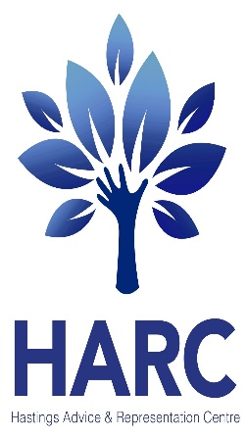
EAST SUSSEX WELFARE BENEFITS HELPLINE
Free advice for all East Sussex residents, staff and volunteers.
TELEPHONE: 03333440681 Mon-Fri 9am-5pm
and HARC ADVICE CENTRE For Hastings and Rother residents
TELEPHONE: 01424 428375
EMAIL: benefitseastsussex@harcuk.com
Or info@harcuk.com
Welfare Benefit Checks to maximise income, debt advice, Help completing benefit applications, clarify benefit queries, Represent with mandatory reviews and benefit appeals.
The Advice and Community Hub
Renaissance House, London Road, St Leonards on Sea, East Sussex, TN37 6AN
As at November 2020: Telephone, Email and Online Advice & Appointments, reception currently closed to public
HARC is a registered charity

