Beckley Church Fete Dog Show
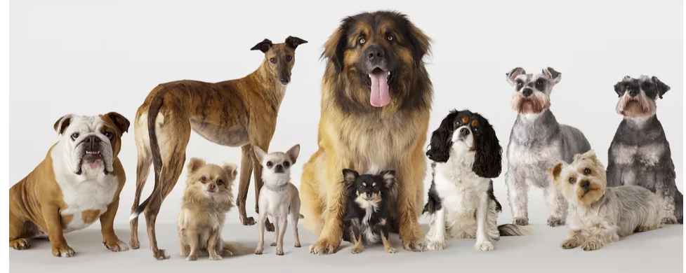
Monday Aug 30th 2021
Beckley Glebe Field
Registration from 1pm Judging from 2pm £1.50 per class or 4 classes for £5
1-Most appealing eyes
2- Best crossbreed
3-Waggiest Tail
4-Best child handler (14 & under)
5-Prettiest Bitch
6-Handsome Dog
7-Best biscuit catcher!
8-Dog the Judge would like to take home.
All 1st and 2nd place winners are invited to compete for best in show at the end.
Sponsored by
www.beckleyboardingkennels.co.uk 01797 260 757

