HELP WITH DENTISTRY
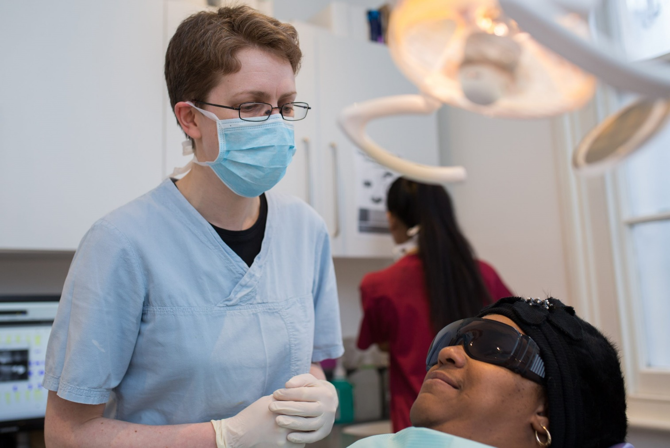

NHS Dentistry – What you need to know
August 13, 2021
Since the pandemic started we have received lots of enquiries about how to access an NHS dental appointment or emergency dental care.
We have put together some key messages to help people understand what dental services are available and how to access them:
- You can contact any dentist offering NHS services. You do not have to be registered with a dentist to seek treatment and there are no geographical catchment areas.
- Whilst many practices are now open again, extra cleaning and social distancing may mean that you may have to wait longer than usual to get an appointment.
- Dentists are private businesses who may choose to deliver NHS services alongside private treatments. The NHS contract identifies which treatments may be offered and what the charges for patients will be.
- When you contact a dentist, you may get asked questions to help the surgery decide how urgently you need to be seen (triage). You may be offered a phone call with a dentist if they cannot see you in person, and this may result in you being offered advice, antibiotics or analgesia (pain relief).
- You should always confirm with the dentist what the costs of your dental treatment plans will be, and whether the treatment being offered is either NHS or private care before proceeding.
- If you require urgent or emergency medical help. When calling a practice you are advised not to ask if the practice is taking on new NHS patients as that may be interpreted as a request for non-urgent care. Instead, you should explain that you have an urgent dental need and the impact(s) your dental problem e.g. causing difficulties eating.
We have summarised some of these key facts in our flyer: Getting-NHS-Dentistry-in-East-Sussex

How do I find a dentist accepting NHS patients?
To find an dentist accepting NHS patients in your area, you can use the NHS ‘Find a dentist’ website or call the Sussex Dental Helpdesk on 0300 123 1663 (Monday – Friday 8am – 4 pm).
Details are shown on individual dental surgeries and the services they offer. Please note that not all website listings show which dentists are currently taking on NHS patients, and you may need to contact surgeries.
If when making contact with surgeries they indicate that they aren’t currently taking on NHS patients, it may be useful to ask when they might expect to.
If you are struggling to access an NHS dental appointment and require impartial advice or information about an oral health issue, the Oral Health Foundation may be able to help. Information is available from the charity’s website or you can contact them on 01788 539 780.

I need dental treatment urgently – how can I get help?
To get the help you need you can:
- Phone your dentist to get information about their opening hours and advice on where you can go to get the care you need.
- You can contact any dentist for advice. Remember you don’t need to be registered with a dentist in the same way as you do with your GP, so you can also see any dentist.
- A dentist may make a referral for you to one of the Urgent Dental Care Hubs in Sussex. Please note that you cannot self-refer to one of these Hubs. You can be referred to a Hub for urgent dental treatment if you have symptoms of COVID-19 or are vulnerable or shielding, although you will be seen at dedicated sites only.
- If you don’t have a dentist or your dentist is closed, you can phone NHS111 (open 24 hours a day, 7 days a week). Translation services are available. If you are deaf or hard of hearing visit https://interpreternow.co.uk/nhs111.
- The East Sussex Emergency NHS Dental Service offers out of hours temporary urgent treatment to patients who reside in East Sussex. Patients contacting the service will be triaged and an appointment will be offered to those that meet the criteria.
Weekday evenings – appointment line live from 6.30pm to 10.30pm with appointments between 7.00pm to 9.00pm: Eastbourne 01323 449170 Hastings 01424 850792 Lewes 01273 486444
Weekends and Bank Holidays – appointment line live from 9.00am to 1.30pm with appointments between 10.00am to 12.00pm: Hastings 01424 850792 Lewes 01273 486444
If you’re in pain while waiting to see a dentist, NHS 111 can also offer other self-care advice.
Please do not visit a Dental Surgery or Urgent Dental Care Hub without an appointment.

What dental services do the NHS provide and how much do they cost?
The NHS provides essential treatments needed to keep your mouth, teeth and gums healthy and free of pain. Any treatment that is clinically necessary should be available from a dentist offering NHS services.
You pay a contribution towards the cost of your care and are charged for treatments depending on which band they fall into.
The treatments bands and costs are set out in the following NHS flyer: What can your NHS dentist do for you
You don’t have to pay for NHS dental treatments if you are:
- under 18, or under 19 and in full-time education
- pregnant or have had a baby in the previous 12 months
- being treated in an NHS hospital and your treatment is carried out by the hospital dentist (but you may have to pay for any dentures or bridges)
- receiving low income benefits, or you’re under 20 and a dependent of someone
- receiving low income benefits.
For information about getting help with dental costs, please visit the NHS website.

How is NHS Dentistry for you?
Tell us your experience of NHS dentistry in East Sussex? Was it good, bad or indifferent?
We want to hear what it was really like for you and help to make changes for other people.
You can leave a review of your experience on our Feedback Centre or contact our team and tell us how it was for you?
Telephone: 0333 101 4007
Email: enquiries@healthwatcheastsussex.co.uk

