Main Street, Beckley - Drainage Works
Monday 13th December 2021 for 5 Days

Scheme Location:
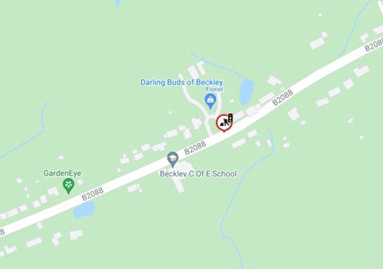

Scheme Information:

What works are taking place?
We will be carrying out drainage works on Main Street, Beckley.

When will these works start?
Work will start on Monday 13th December 2021 and continue for five days.

Traffic Management
Main Street will remain open with temporary traffic lights and parking restrictions in place between Whitehorns & Brick Kiln Cottage. There will be ‘no parking’ signs and cones on site to advise where parking is restricted.
Please also see our website for information about these works: https://www.eastsussexhighways.com/highway-schemes/main-street-beckley-drainage

Feedback: Let us know how we did by leaving us feedback.

