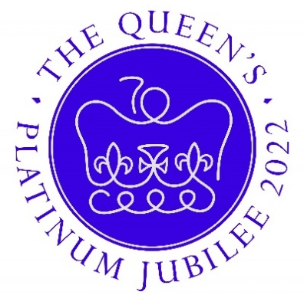

FREE EVENTS FOR VILLAGERS
These events are possible thanks to Beckley Parish Council and Rother District council providing funds to help cover the costs.
THURSDAY 2ND JUNE
10am-Special church service to be attended by the Lord Lieutenant. Be in church for 9.45am.
10.30am-Tree planting ceremony & time capsule burial in church yard followed by refreshments. Everyone welcome. The children’s poetry entries will be displayed in the church.
1pm start children cinema- village hall. Doors open 12.30 (duration I h 40mins)
3pm-cinema film of Queens Jubilee 1953 & local movies from past events- village hall
8pm cinema film for grownups- village hall
FRIDAY 3RD JUNE
2pm Talk on the church & the historic village trees. Meet at church.
7.30pm- Henry VIII is coming to the village hall for an amusing talk on his life and loves!
SATURDAY 4TH JUNE
10-11 am Exhibits for Horticultural Flower and craft show with jubilee classes (see Schedule) to be dropped off (small charge for entries). Show opens at 2pm
2pm Beckley Bowls are holding an open day so locals can try out bowls.
2.30pm A guided walk around the revamped frog field.
SUNDAY 5TH JUNE
12 noon - 6pm Picnic in the Glebe Field with R&C bar, ice creams and Musical entertainment from the Stephensons & Chris Fisher.
ART TRAIL- ALL WEEKEND
Beckley School & Preschool have made some art installations that are located around the village starting at the church and ending at the Jubilee Field.

