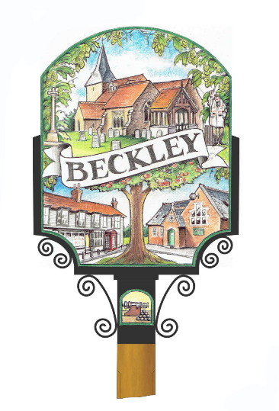
Welcome To Beckley
The Parish Council would like to take this opportunity to welcome you to our village. This welcome leaflet is sponsored and produced by the Beckley Parish Council. You are invited to attend the monthly meetings (every second Tuesday of the month @7.30pm in the Village Hall) and find out how we care for your village www.beckleyparishcouncil.org.uk CLERK - VALERIE ADES clerk@beckleyparishcouncil.org.uk Tel: 01424 845456 - FB = Beckley Parish Council Information.
Please find below a list of useful numbers for local clubs and village amenities etc.
Defibrillators (3) Phone box opposite the Rose & Crown, Main Street, wall outside the Village Hall, Main Street and on the wall outside Ebofrost factory, Hobbs Lane.
Library - Phone box opposite the School houses books etc for residents to swap and read.
Butterflies-Babies & Toddler Group – Village Hall Monday - term time- 9.15-11.15am £2.50 a family.
Beckley Preschool- Village Hall- term time Mon 9-3 Tues 9-3 Wed 9-1 Fri 9-3- 01797 260 582- www.bpnn.co.uk FB = Beckley Preschool.
Village Primary School - 01797 260 342- www.beckley.e-sussex.sch.uk FB=Beckley School Association Events.
Messy Church - Beckley Church- bandpmessychurch@gmail.com
All Saints Church – services 8am Sundays and some 10am services.
Parish magazine available as a hard copy or online. Details from boatwrightsmith@aol.com www.beckleyandpeasmarshchurch.co.uk FB page = Beckley and Peasmarsh Church
Friends of Beckley Church - village coffee morning with charity stall - 1st Tuesday- 10.30-12.30-Village Hall- 01797 260775.
Farmers Market – held every 4th Sunday of the month - Village Hall- 10-12pm FB page = Beckley farmers and craft market.
WI – 2nd Monday 7.30pm – Village Hall - 01797 260450
Trefoil 3rd Monday – Village Hall- 01797 260537
Self-defence Weds Village Hall 7-9pm shingitaimrb@gmail.comor 07713 429642
Taekwondo every Wednesday - 430pm Village Hall- Start from age 5. Petra 01233 642357
Brownies & Guides - Thursdays vill hall 6.30pm jaybeckleybrownies@gmail.co.uk
Table Tennis - Every Thursday- 9.30-11.30am– Village Hall- 01797 252382
Tennis Court/MUGA - (tennis, basketball, netball or football). Located at top of the Playing fields free to play if vacant. Bookings can be made via FB: Beckley Multi Use Games Area or https://beckleymuga.setmore.com/
Hatha Yoga Thursdays 9.30-11am ajfgill@gmail.com 07913 615984
Lunch Club - All ages- 2nd Thursday-Village Hall- 12.30pm 01797 260720

History Society - Contact (Chairman): 01797 260213 mary260213@aol.com

Horticultural Society - katejmjoyner@gmail.com or 01797 260775.https://beckleyhorticulturalsociety.org

The Growing Network - food/seed sharing 1st sat of month Beckley Village Hall 11-12.30
FB=The growing network (Beckley E.Sussex).
Beckley Players (Am/Dram) - 07974 928665
Beckley Bowls - 01797 260537
Beckley Cricket Club - 07599175491
Beckley Rangers-football - Graemedinning@hotmail.co.uk
Village Hall Hire - 01797260213 Rother Lottery supports the village hall. For more info Rothercommunitylottery.co.uk
Doctors – Northiam Surgery- 01797 252341 Dentist- Northiam- 01797 252727
Vets- Badgers Oak – Northiam 01797 252321
Beckley Boarding Kennels - 01797 260757 info@beckleyboardingkennels.co.uk
Rose & Crown Pub - Alice 01797252161 takeaways available.
Beckley Community Speed watch Group - www.communityspeedwatch.co.uk
Post Office - Jempsons in Peasmarsh & Northiam.
Bin Collection - Every Tuesday One week black wheelie following week Green recycling. further information www.rother.gov.uk 01424 787000 Also Brown garden waste bin is chargeable. Contact the same number.
Cash Points - Jempsons garage and supermarket in Peasmarsh or small Jempsons store in Northiam. (All Jempsons stores close on Sundays).
Beckley has some other Facebook pages not mentioned above: Search for the groups:
FB= Beckley Bulletin Board, Beckley Village Society, Better Beckley Project, Bargains in Beckley, Businesses in Beckley and nearby, Beckley Baby & Children’s Bargains.

